Lightened Dream

# Quick Start Guide

Lightened Dream is a dream journal designed to wake you up in your dreams.

*“Follow its directions and you will be bending the*

*laws of reality while getting a good night’s rest.”*

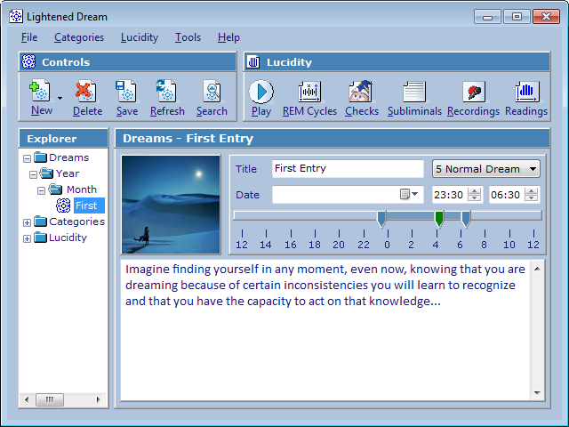



Dreams

# Creating a new dream

To create a new dream, simply click on **New** and select **Dream**.

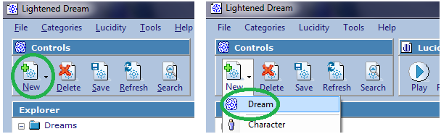

Then type a title for the dream and write down as many details as you can remember.

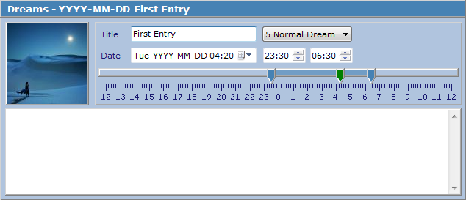

To generate a list of common dream signs / category items, click on **Tools** and then select **Dream Sign Builder**. This will chart the 10 most used words, which can be clicked on to either be ignored or added to a category.

# Saving

To save changes to a dream or any other Lightened Dream File, click on **Save**.

# Deleting

To delete a dream or any other Lightened Dream File, click on **Delete**.

Categories

# Creating a new category item

To create a new category item, simply click on **New** and select one of the categories (**Character, Location, Object, Action, Theme** or **Emotion**).

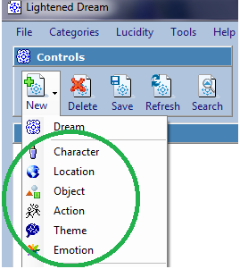

Then type a title and description for the item. The **Words** field can be used to save words with similar meanings to the item so that it is linked up with those words too. The words can be entered in a comma separated list, e.g.: word1, word2, word3.

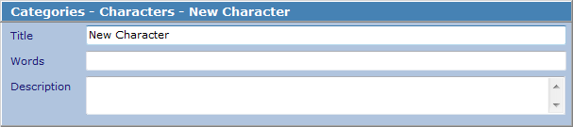

Saving a category item will plot a graph with each dream that contains that item. The graph can be clicked on to load a dream.

After saving a dream, a list of unassigned words will be displayed below the dream that can be dragged and dropped into a category, e.g.:

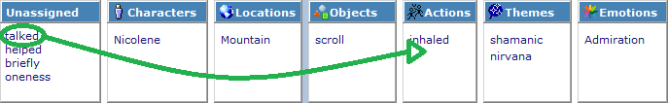

Lucidity

# REM (rapid eye movement) Cycles

The cycles are designed to be played on a computer within earshot of where you sleep. The trick is to keep changing the time when you start a file until you have a feel for when you will be dreaming. And the idea behind this is to trigger an effect in you dream, e.g.: lucidity. Just like an alarm clock will wake you up completely and a soft radio or television might bleed some content into a dream, cyclesallow you to control this effect more precisely.

To create a new REM cycle, click on **New** and select **REM Cycle**.

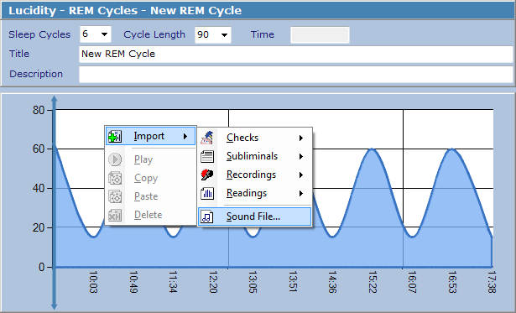

The **Cycle Length** field determines how long, in minutes, a sleep cycle should last. On average, the first few sleep cycles last 90 minutes and get shorter from then on. And the REM phase occurs at the end of a sleep cycle. This is, of course, different for each person and different again each day, depending on a number of variables.

The **Sleep Cycles** field determines the amount of cycles to graph and the total length of the file. E.g.: 90 minutes × 6 cycles = 540 minutes = 9 hours.

To add a new file to a cycle: right-click on the graph and select **Import**. From there it can be moved to any location by dragging the small “x” at the bottom of the cloud. When you click on **Play**, the cycle will begin and as each minute passes any files assigned to that minute will be triggered.

REM cycles and any other Lightened Dream files (.ld3) can be shared with other users: right-click on the file in the tree-view on the left and select **Open File Location** or **Copy To** and then **Desktop** to view the file in Windows Explorer.

# Reality Checks

Merlin is back, by popular demand. Merlin is a Microsoft Agent character that can be controlled through a sequence of actions and written dialogs that can be spoken through a TTS (Text To Speech) engine. The idea is to design a bunch or reality tests (e.g.: What did you do an hour ago?) and have Merlin play them throughout the day while you are working on your computer. Then, you should eventually dream of them and hopefully realize that something is different.

To play reality checks in the background, simply click on the **Play** button while in the folder / list view of the reality checks. It will start with a random check and then keep running at random intervals.



To create a new check, click on **New** and select **Check**. Then click on **Add Item** and either select an action for Merlin to perform or type some text for him to speak. Then click on **OK** to add the item to the sequence. Keep adding items

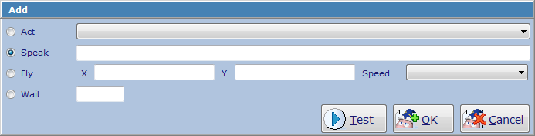

Merlin might not run on Windows 7 machines out of the box. If Merlin does not work for you, please read this Microsoft Support article: <http://support.microsoft.com/kb/969168> and request the correct installer for your platform (x86 or x64) from here: <http://support.microsoft.com/hotfix/KBHotfix.aspx?kbnum=969168&kbln=en-us>. Or click on **Help** -> **Support** for personal assistance with this.

# Subliminal Messages

Subliminal messages can be used in the background while working on your computer to program you subconscious mind.

To create a new subliminal file, click on **New** and select **Subliminal**.

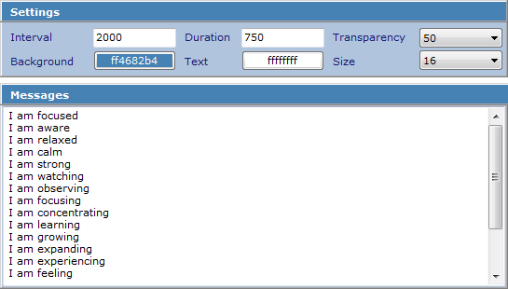

The **Interval** controls how long, in milliseconds (one second = 1000 milliseconds), to wait between displaying messages. The **Duration** determines how long to display a message on the screen. A **Transparency** value of 0 is completely opaque and a value of 100 is totally see-through.

In this example, a semi-transparent message from the list will be displayed randomly on the screen every two seconds for just under a second (0.75):



# Readings

Readings can be used either as a form of slow meditative reading, or a type of subconscious speed-reading to incubate / pre-program dreams.

To create a new reading, click on **New** and select **Reading**. Then set the **Interval** (again, in milliseconds). Note: if you click on the “Readings” label just above the free text, it will replace any spaces with a new line – to quickly make copied text from a novel display one word at a time.

# Recordings

Recordings are designed to be imported into REM cycles but can also be used to make a quick voice recording of a dream for later transcription.

To create a new recording, click on **New** and then **Recording**.

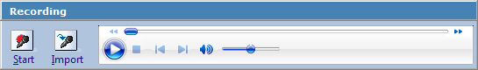

Then click on **Start** to begin recording any input from the microphone and **Stop** to end the recording and play it back. Alternatively, the **Import** button can be used to import any existing sound files (e.g.: mp3, wav) from your machine. And if any text is type into the area below the recording panel, it will be spoken via TTS.

# Exercises



The exercises are designed to increase lucidity and you should aim to do one a day. Your progress will be charted over the months.

To perform an exercise, click on **New** and then select **Random Exercise**. If you do not wish to follow the instructions right away, delete it. Advanced users should create their own exercises. The drop down list with the numbers represents the power of the exercise / how likely it is to help one attain lucidity.

If you have any good exercises that you would like to share, please click on **Help** -> **Support** and send it off as a contribution. The best exercises will be released in future updates.

Pro Tips

# Dream Recall

If you don’t remember any dreams, simply think through your day in fast-rewind mode before falling asleep. Works. Every. Time.

# Community

If you have any questions or would like to read more about lucid dreaming, then join the [Dream Views](http://www.dreamviews.com/forum.php) community where I can be found under the handle **IAmCoder**.

# Why LD

If you have read this far, then what you are currently doing, how you practice lucidity from day to day, is probably good enough as it is - what you need to change or improve is why you are doing it.